2021 和信Breast（蔡醫師出了15題）
- 簡述Hypofractionation evidence
看105% hot spot
Axilla有還是可以做
只有T1-2N0才可以做（選他，錯的選項）
- PBI indication？為什麼不做？
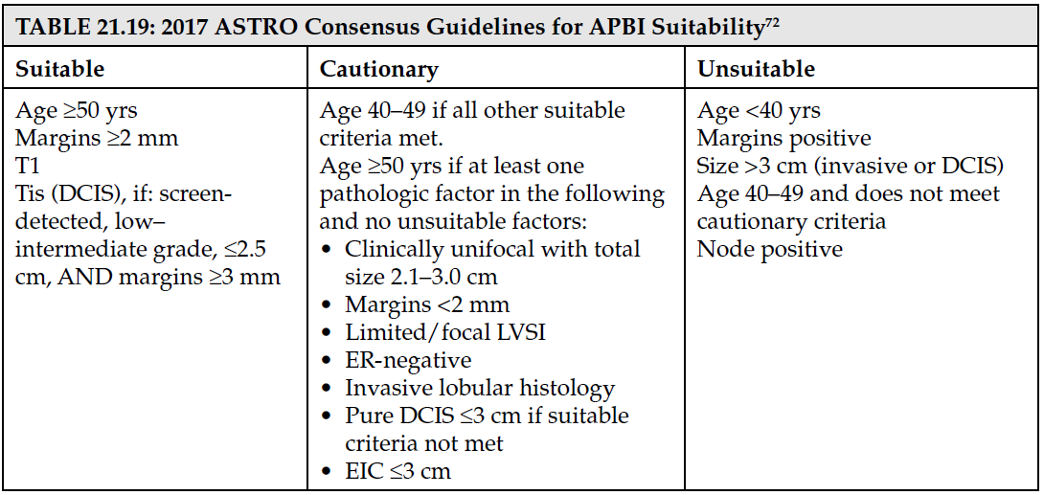
- SLN+ ( Z0011, AMAROS)
AMAROS 10yr OS axillary RT比上ALND掉很多？蔡醫師說paper沒解釋到這塊
SLN+, 如何考慮要不要RNI:考慮 size, 淋巴結顆數, 淋巴結清的多寡, grade 低, ER(+)
- RNI:
N1(1-3顆淋巴結轉移)：在我們醫院只有12%沒有做放射線治療
EORTIC 22922 marginal survival benefit
DBCG-IMN:內側/中間1-3, N2, >5cm favor IMNI
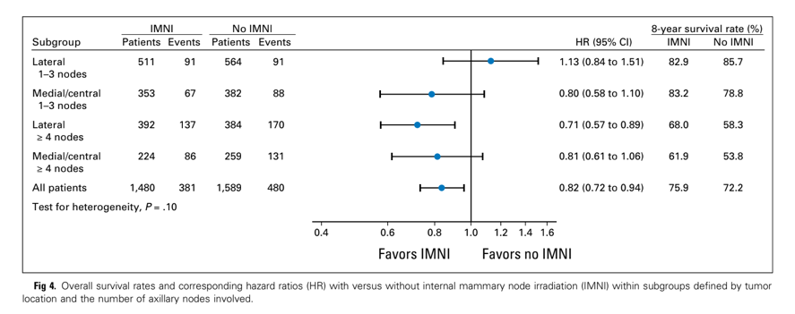
- 簡單如何跟病人說明開保留手術後RT的好處
- Mammogram screen從45（他題目出40y/o）-69歲可以降低23-30%死亡率, 40-44歲有二等親才需要mammo screen
國健局45-69y/o
BIRADS 0-6的定義, 要做什麼後續的安排
高風險族群做MRI
- BRCA mutation
NCCN建議MRI追蹤, 但一年復發率也只有3-4%, 所以實務上用一般檢查追蹤
NCCN建議何時做genetic test? Triple negative<60y/o, <40y/o, <50y/o first degree with prostate, pancreatic, 本人ovarian cancer?
Breast cancer with BRCA mutation美國比例約10%, 台灣5-7% (cf NPC 7%有家族史)
25歲開始screen breast cancer, 30-35歲開始screen ovarian cancer

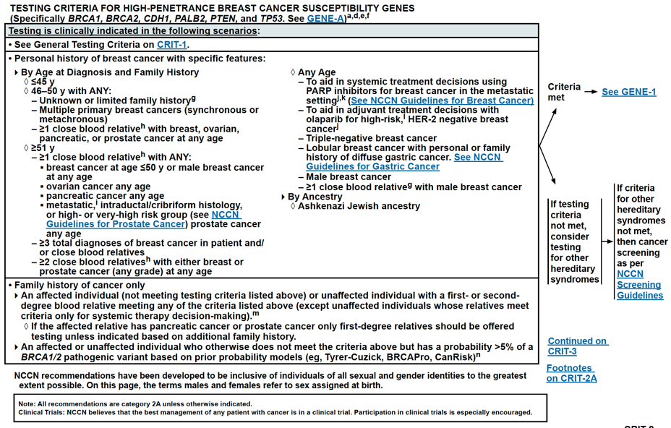
- LCIS如果開刀邊緣陽性要請他回去開刀,答案是錯！
Pleomorphic LCIS outcome和DCIS差不多, 所以蔡醫師也有照
- DCIS
margin 2mm, IDC margin: no ink on tumor
沒有trial比較mastectomy和BCS+RT (Perez p1261)
50% HER2 positive (cf: IDC 10-30%)
Tamoxifen
B24降低local recurrence2-3%(16.6 13.2%, HR 0.68), 降低對側乳癌一半(8.1 6.9, HR0.68), no OS benefit, 增加Endometrial cancer 3/1000(主要在55-60y/o) (UK說local control 沒有)
P1 as prevention乳癌機率下降by 49%但是s/e…
Margin(+)加tamoxifen有好處但臨床會再去開刀
RT可以降低10yr absolute IBTR: 18%, relative: 52%

- Favorable histology：NCCN: pure tubular, mucinous, cribriform, encapsulated or solid papillary carcinoma, Adenoid cystic and other salivary carcinoma, secretory carcinoma, rare low grade forms of metaplastic carcinoma
他說有metaplastic那個選項是錯的
- Level I-III是由pectoralis minor 區分
- Omit WBI: only N0, 多老是old age?
CALGB 9343相較於hormone therapy alone降低多少local recurrence: 5y: 4%--> 1%, 10y: 10%-->2%

